Write a program that shows the following menu options and lets the user to convert from Metric to Imperial system:

**Converter Toolkit**

**--------------------**

**1. Temperature Converter**

If the user enters 1, the program should ask for the temperature in Celsius and convert it to Fahrenheit

**2. Distance Converter**

If the user enters 2, the program should ask for the distance in Kilometer and convert it to Mile

**3. Weight Converter**

If the user enters 3, the program should ask for the weight in Kilogram and convert it to Pound

**4. Quit**

If the user enters 4, the program should end.

**Project Specifications**

**Input for this project:**

* the user must enter an number to select a menu option
* the user must enter temperature in Celsius
* the user must enter distance in Kilometer
* the user must enter weight in Kilogram
* the user must enter a country name

**Input Validation:**

* Do not accept a number outside the range of 1 through 4 for the menu option. Be sure to display appropriate error message if the input is invalid.
* Do not accept negative numbers for distance and weight. Be sure to display appropriate error message if the input is invalid.

**Output: The program should display the following:**

* a menu for Converter Toolkit
* temperature in Fahrenheit, distance in miles or weight in pounds
* a country name
* Programmer’s full name
* project number
* a due date

**Processing Requirements**

1. The program should use at least one selection control structure (if – else statement)
2. Be sure to convert as specified. For example, convert temperature from Celsius to Fahrenheit, not the other way around.
3. **Use the following for converting input:**

* **1 kilometer = 0.6 mile,**
* **1 kilogram = 2.2 pounds,**
* **The formula for converting Celsius degree to Fahrenheit is:**

***F = (9/5)*C + 32* where** **F is the temperature in Fahrenheit and C is the temperature in Celsius**

1. Convert temperature to a whole number such as 78, distance to two positions after decimal point (for example 84.56) and weight to one position after decimal point (For example 121.6).

**Project Description**

There are two main systems for measuring **distance**, **weight** and **temperature**

* the Imperial System of Measurement
* the Metric System of Measurement

Most countries use the **Metric System**, which uses the measuring units such as **meters** and **grams** and adds prefixes like **kilo**, **milli** and **centi** to count orders of magnitude.

In the United States, we use the older **Imperial system**, where things are measured in **feet**, **inches** and **pounds**.

**Sample Screen Output #1:**

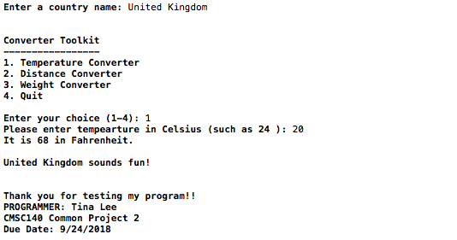

**Sample Screen Output #2:**

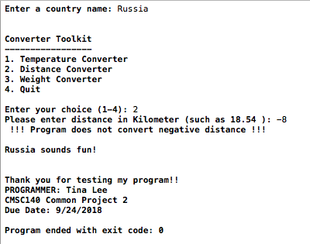

**Special Project Submission Requirements**

**Deliverables:**

* Intermediate deliverable:

Program design- Flowchart and/or pseudo code for the Program due one week after project is given. An intermediate assignment will be created for submission. Flowchart/pseudo code can be submitted electronically in the following format: word document, pdf or handwritten flowchart/pseudo code picture saved as .jpg or png.

**NOTE**: Be sure to check also

1. CMSC140 Common Project Submission Requirements (.docx)
2. CMSC140 Grading Rubric_CheckList-Project 2 (.xlsx)

**Test Plan**

Test your program with at least two more test cases. Use the given data as an example. Record your data for input and output in the following table. **Make sure your tests cover all the possible scenarios.**

|  |  |  |  |  |  |
| --- | --- | --- | --- | --- | --- |
| **Test Case #** | **Input** | **Actual Input** | **Expected Output** | **Actual Output** | **Did the test pass?** |
| 1 | Choice 1  Temp 20 |  | 68 |  |  |
| 2 | Choice 2  Distance -8 |  | Error message |  |  |
| 3 |  |  |  |  |  |
| 4 |  |  |  |  |  |